Enteric disease surveillance and outbreak investigations in Western Australia



**Enhancing foodborne disease surveillance across Australia**



2023 annual report

OzFoodNet, Communicable Disease Control Directorate

**Acknowledgments**

Acknowledgement is given to the following people for their assistance with the activities described in this report: the staff from PathWest Laboratory Medicine WA; scientific officers from Environmental Health Directorate of the Department of Health, Western Australia; public health nurses and doctors from metropolitan and regional areas; and local government environmental health officers.

**Contributors/Editors**

Deirdre Collins, Barry Combs, Stacey Hong, Katherine Lim

Communicable Disease Control Directorate

Department of Health, Western Australia

PO Box 8172

Perth Business Centre

Western Australia 6849

Email: [OzfoodnetWA@health.wa.gov.au](mailto:OzfoodnetWA@health.wa.gov.au)

Telephone: (08) 6376 0514

Web:

OzFoodNet Department of Health, WA

<https://ww2.health.wa.gov.au/Articles/F_I/Infectious-disease-data/Enteric-infection-reports-and-publications-OzFoodNet>

OzFoodNet Department of Health and Ageing

<https://www1.health.gov.au/internet/main/publishing.nsf/Content/cdna-ozfoodnet.htm>

**Disclaimer**:

Every endeavour has been made to ensure that the information provided in this document was accurate at the time of writing. However, infectious disease notification data are continuously updated and subject to change.

# Executive summary

This report is a summary of enteric infection surveillance activities and outbreak investigations in Western Australia (WA) in 2023. Enteric infections are gastrointestinal tract infections commonly resulting in gastroenteritis or ‘gastro’ which cause a large burden of illness. In WA, there are 15 enteric infections and one enteric infection-related condition that are notifiable to the WA Department of Health. The Department of Health through OzFoodNet (OFN) and other agencies conduct surveillance and investigate outbreaks to monitor infection trends and ensure that timely interventions and policies can be implemented to prevent further transmission.

In 2023, there were 8,179 notifications of enteric infections in WA, which was a rate of 304 per 100,000 population. The 2023 rate was 31% higher than the average rate for the previous five years. The age group with the highest enteric infection rate was 0–4 years with 734 cases per 100,000 population. The rate of enteric infection for Aboriginal people was 19% higher than for non-Aboriginal people. Of the notified enteric infections with a known place of acquisition, 71% reported acquiring their infection in WA, 28% reported overseas travel and 1% reported interstate travel.

As with previous years, campylobacteriosiswas the most commonly notified enteric infection in 2023 (n=4,820; 59%) followed by salmonellosis (n=1,427; 17%); notification rates were 38% higher and 11% lower than the previous five-year average, respectively. Notification rates of most (10/16) of the notifiable enteric infections/syndromes in 2023 were higher than the previous five-year average. This increase is likely to be partly due to more overseas travel following the relaxing of COVID-19-related restrictions in 2022. Notable increases were observed for yersinosis (n=98, 4-fold increase), paratyphoid fever (n=15, 3.8-fold increase), rotavirus (n=911, 2.1-fold increase) and typhoid fever (n=22, 1.85-fold increase).

**Foodborne and probable foodborne outbreaks**

In 2023, there were seven outbreaks of probable foodborne and foodborne infection investigated in WA that caused at least 110 cases of illness. Of these, five were caused by *Salmonella* and one outbreak each was caused by Shiga toxin-producing *Escherichia coli* (STEC) and *Campylobacter*.

Food vehicles were identified in three outbreaks (43%, n=3). There were four outbreaks where a food vehicle was not identified, however, there was strong descriptive evidence to suggest transmission was probable foodborne.

Table A: Number of foodborne outbreaks investigated by causative agent, WA, 2018 to 2023



**Non-foodborne enteric infection outbreaks**

Non-foodborne enteric infection outbreaks and outbreaks with an unknown mode of transmission are a major cause of illness, especially in institutions such as residential care facilities (RCFs) and child care centres (CCCs). There were 219 non-foodborne outbreaks reported in 2023, which resulted in 3,866 ill people, 71 hospitalisations and 18 associated deaths. Most of these outbreaks were in RCFs and CCCs and due to person-to-person transmission. The number of outbreaks peaked in the fourth quarter of 2023 with 88 outbreaks, compared to the second quarter with 23 outbreaks.

# Table of contents

Executive summary 3

Table of contents 5

Introduction 8

Data sources and methods 10

Data sources 10

Aboriginal status 11

Regional boundaries 11

Calculation of rates 11

Definitions related to outbreaks 12

Site activities during the year 13

Surveillance and investigation 13

Activities to enhance laboratory and epidemiological surveillance 13

Activities to assist enteric disease policy development 14

Strengthening skills and capacity for enteric infection surveillance and investigation 14

Conference meetings and presentations 15

Notifications and rates of specific enteric infections 16

Botulism 16

Campylobacteriosis 16

Cholera 18

Cryptosporidiosis 18

Haemolytic Uraemic Syndrome (HUS) 20

Hepatitis A infection 20

Hepatitis E infection 21

Listeriosis 21

Rotavirus infection 22

Salmonellosis 24

Shiga toxin-producing *E. coli* (STEC) infection 28

Shigellosis 29

Typhoid and paratyphoid fever 31

*Vibrio parahaemolyticus* infection 32

*Yersinia* infection 32

Gastrointestinal infection outbreaks and investigations 32

Foodborne and probable foodborne outbreaks summary 32

MJOI of foodborne and probable foodborne outbreaks in WA 37

Significant foodborne and probable foodborne outbreak summaries 37

Outbreaks due to non-foodborne transmission or unknown mode of transmission 40

Cluster investigations 42

References 43

Appendix 1: Number of notifications, notification rate2 and ratio of current to historical average by pathogen/condition, 2018 to 2023, WA 44

List of tables

Table 1 Number and proportion of the top 10 *Salmonella* serotypes notified in WA, 2023, with comparison to the previous five-year average 27

Table 2 The 10 most common *S*. Typhimurium MLVA types reported in 2023 28

Table 3 Foodborne and probable foodborne outbreaks, 2023 34

Table 4 Outbreaks due to non-foodborne or unknown mode of transmission in WA by setting and agent, 2023 41

Table 5 Cluster investigations in WA by month investigation started, setting and agent, 2023 42

List of figures

Figure 1 Campylobacteriosis notifications by year and month, WA, 2018 to 2023 17

Figure 2 Campylobacteriosis notification rate by age group and sex, WA, 2023 17

Figure 3 Campylobacteriosis notification rates by region and Aboriginality, WA, 2023 18

Figure 4 Cryptosporidiosis notifications by year and month, WA, 2018 to 2023 19

Figure 5 Cryptosporidiosis notification rate by age group and sex, WA, 2023 19

Figure 6 Cryptosporidiosis notification rates by region and Aboriginality, WA, 2023 20

Figure 7 Place of acquisition for hepatitis A notifications, 2018 to 2023 21

Figure 8 Notifications of listeriosis showing non-pregnancy related infections and deaths, and materno-foetal infections and deaths, WA, 2018 to 2023 22

Figure 9 Rotavirus notifications by year and month, WA, 2018 to 2023 22

Figure 10 Rotavirus notification rates by age group and sex, WA, 2023 23

Figure 11 Rotavirus notification rates by region and Aboriginality, WA, 2023 24

Figure 12 Salmonellosis notifications by year and month, WA, 2018 to 2023 24

Figure 13 Salmonellosis notification rate by age group and sex, WA, 2023 25

Figure 14 Salmonellosis notification rates by region and Aboriginality, WA, 2023 26

Figure 15 Salmonellosis notifications by place of acquisition and year, 2018 to 2023 26

Figure 16 STEC notifications by year and month, WA, 2018 to 2023 28

Figure 17 STEC notification rates by age group and sex, WA, 2023 29

Figure 18 Shigellosis notifications by year and month, WA, 2018 to 2023 30

Figure 19 Shigellosis notification rates by age group and sex, WA, 2023 30

Figure 20 Shigellosis notification rates by region and Aboriginality, WA, 2023 31

Figure 21 Number of non-foodborne gastroenteritis outbreaks by mode of transmission and month, 2023 41

# Introduction

It has been estimated that there are 5.4 million cases of foodborne illness in Australia each year, costing $1.2 billion per year1. This is likely to be an underestimate of the true cost of enteric illness in Australia, as not all enteric infections are caused by foodborne transmission. Other important modes of transmission for enteric infections include person-to-person, animal-to-person and waterborne transmission. Most enteric infections are preventable through interventions at the primary production level, institutional infection control, food handling and hand hygiene at food businesses and in households.

This report describes the epidemiology of enteric infection and outbreak investigations in WA undertaken by OzFoodNet (OFN) Western Australian (WA) branch and other WA government agencies in 2023. Most of the data presented in this report is derived from enteric infection notifications from doctors and laboratories received by the WA Department of Health and are likely to underestimate the true incidence of infection. This data nevertheless remains the most important information on incidence of these infections for surveillance purposes in WA. In addition, this report describes gastroenteritis outbreaks in facilities including residential care facilities (RCF), child care centres (CCC), and in the general community. These outbreaks are often due to norovirus which is not notifiable.

OFN is part of the Communicable Disease Control Directorate (CDCD) of the WA Department of Health and is also part of a National OFN network funded by the Commonwealth Department of Health and Aged Care2. The mission of OFN is to conduct enhanced surveillance of foodborne illness in Australia and to conduct applied research into associated risk factors. The OFN site based in Perth is responsible for the whole of WA. Collaboration between States and Territories is facilitated by circulation of fortnightly jurisdictional enteric surveillance reports, monthly teleconferences, bi-annual face-to-face meetings and general email correspondence through the OFN network. This network also includes communication and consultation with Food Standards Australia New Zealand, the Commonwealth Department of Health and Aged Care, the National Centre for Epidemiology and Population Health, the Communicable Diseases Network of Australia and the Public Health Laboratory Network.

The primary aims of OFN nationally are to:

* investigate the epidemiology of foodborne infections, conduct enhanced surveillance and collaborate on relevant studies,
* collaborate nationally to coordinate investigations into foodborne infection outbreaks, particularly those that cross State, Territory and country borders,
* identify foods and commodities that cause human infection, providing relevant information to stakeholders, advocacy for policy development and implementation, and contributing to risk assessments,
* contribute data to inform the estimation of the incidence and cost of foodborne infection in Australia,
* develop and maintain skills and capacity for the epidemiological investigation of foodborne infections.

At a local level, OFN conducts surveillance of enteric infections to identify clusters and outbreaks of specific infections and conducts epidemiological investigations to determine the cause of outbreaks. OFN also conducts research into the risk factors for sporadic cases of enteric infections and develops policies and guidelines related to enteric infection surveillance, investigation and control. OFN regularly liaises with staff from the Population/Public Health Units (PHUs), the Environmental Health Directorate of Department of Health, WA (EHD); and the Microbiology Department (encompassing Environmental and Food, Enteric, Bacteriology, and Microbiology Surveillance laboratories) at PathWest Laboratory Medicine WA (PathWest).

CDCD maintains and coordinates the WA notifiable disease surveillance system and provides specialist clinical, public health and epidemiological training and advice to PHUs. The WA notifiable diseases surveillance system relies on the mandatory reporting by doctors and laboratories of notifiable infectious diseases and disease-related conditions, 16 of which are enteric diseases.

PHUs are responsible for public health activities in their WA administrative health regions, which includes communicable disease control activities. Three of the regions are in the Perth metropolitan area (East, North and South) and seven in the regional areas are Goldfields (GOLD), Great Southern (GSTH), Kimberley (KIMB), Midwest (MIDW), Pilbara (PILB), South West (STHW) and Wheatbelt (WHEAT).

The PHUs monitor RCF and CCC gastroenteritis outbreaks and provide infection control advice. The PHUs also conduct follow up of single cases of important enteric infections including typhoid, paratyphoid, hepatitis A and E, cholera and *Shigella dysenteriae*. OFN will also assist with the investigation of these enteric infections if there is a cluster and/or they are locally acquired. In addition, OFN will investigate gastroenteritis outbreaks due to probable foodborne transmission in RCF and CCC settings.

The EHD liaises with Local Government (LG) Environmental Health Officers (EHOs) during the investigation of food businesses, and coordinates food business investigations when multiple LGs are involved.

The Environmental and Food, Enteric, Bacteriology laboratories at PathWest provide routine diagnostic services. The Microbiology Surveillance laboratory provide molecular typing and genomic data to inform and enhance outbreak investigations carried out by OFN.

# Data sources and methods

### **Data sources**

WA notifiable enteric infection notification data was obtained from the WA Notifiable Infectious Disease Database (WANIDD). The notifications are reported by medical practitioners and pathology laboratories under the provisions of the Public Health Act 2016 and subsequent amendments, and are retained in WANIDD if the WA 3 or national case definitions are met4.

Notifiable enteric infections included in this report are botulism, campylobacteriosis, cholera, cryptosporidiosis, haemolytic uraemic syndrome (HUS), hepatitis A infection, hepatitis E infection, listeriosis, rotavirus infection, salmonellosis, shiga toxin-producing *Escherichia coli* (STEC) infection, shigellosis, typhoid and paratyphoid fever, *Vibrio parahaemolyticus* infection and yersiniosis. In February 2024, data for these infections were extracted from WANIDD by optimal date of onset (ODOO) for the time period 01/01/2018 to 31/12/2023 and exported to Microsoft® Excel and outgoing excluded. The ODOO is a composite of the ‘true’ date of onset provided by the notifying doctor or obtained during case follow-up, the date of specimen collection for laboratory notified cases, and when neither of these dates is available, the date of notification by the doctor or laboratory, or the date of receipt of notification, whichever is earliest.

Notification data in this report may have been revised since the time of extraction. Subsequent minor changes to the data would not substantially affect the overall trends and patterns.

Information on *Salmonella* and STEC serotypes, *Shigella* species and biotypes, multi-locus variable number tandem repeat analysis (MLVA), multi-locus sequence typing (MLST) and whole genome sequencing (WGS) data of certain pathogens was obtained from PathWest. Other specialised diagnostic data were obtained from the Microbiological Diagnostic Unit, University of Melbourne, and the Australian *Salmonella* Reference Laboratory, Institute of Medical and Veterinary Science (Adelaide).

Information on RCF and CCC outbreaks was collected by PHU staff who forward collated epidemiological and laboratory data to OFN.

### **Aboriginal status**

For the purposes of this report, the term ‘Aboriginal’ is used in preference to ‘Aboriginal and Torres Strait Islander’ to recognise that Aboriginal people are the original inhabitants of WA.

Due to the small size of the Aboriginal population in WA (approximately 4.0% of the total population in 2021) and the relatively large number of cases reported in Aboriginal people, inaccuracies in the population estimates of Aboriginal people can have a disproportionate impact on calculated rates. These factors are acknowledged as limitations. Information on Aboriginality was missing for 5% of enteric notifications in 2023.

### **Regional boundaries**

As mentioned in the introduction, public health activities and notification data is divided into ten WA Health administrative regions based on PHU boundaries. For the purposes of this report, the three metropolitan PHUs have been combined into one ‘metropolitan’ (METRO) region and regional areas include the GOLD, GSTH, KIMB, MIDW, PILB, STHW and WHEAT.

### **Calculation of rates**

Notification rates were calculated by dividing the number of notifications of infections within the relevant population by the total number of people within that population and were expressed per 100,000 population. WA’s estimated population denominators used for calculation of rates were obtained from Rates Calculator version 9.5.5.1 (Epidemiology Branch, WA Department of Health). The Rates Calculator provides population estimates by age, sex, Aboriginality, year and area of residence, and is based on population figures based upon 2016 Australian Bureau of Statistics Census data. Rates calculated for this report have not been adjusted for age. It should be noted that small numbers of notifications give unstable and imprecise notification rates.

### **Definitions related to outbreaks**

**Foodborne outbreak** is where two or more persons experience a similar illness after consuming a common food or meal and analytical epidemiological evidence and/or microbiological evidence (including food and/or environmental) implicates the meal or food as the source of illness; or the aetiology of the outbreak can only result through foodborne transmission (e.g. *Listeria monocytogenes* infection, ciguatera fish poisoning).

**Probable foodborne outbreak** is where two or more persons experience a similar illness after consuming a common food or meal and compelling descriptive epidemiological evidence implicates the meal or food as the suspected source of illness. This includes outbreaks where the mode of transmission is suspected to be from an ill food handler contaminating food being prepared.

**Probable person-to-person outbreak** is where two or more persons develop gastrointestinal symptoms following exposure to a person or group of people, either known or suspected to be infectious, or an environment where an infected person has been known to have contaminated and onset dates of illness suggest ongoing transmission.

**Unknown outbreak transmission** is where two or more persons experience a similar illness but the mode of transmission is unable to be determined.

***Salmonella* outbreak due to an egg dish** is nominated as the implicated food if

* *Salmonella* is isolated from eggs (from the implicated premises) or from the implicated dish containing eggs (microbiological evidence) OR
* There is analytical evidence that a dish containing eggs was associated with illness OR
* In the absence of microbiological or analytical evidence, an implicated dish is described as an egg dish if it contains raw or undercooked eggs and most cases report eating the dish in the absence of other high-risk foods eaten in common.

# Site activities during the year

During 2023 the following activities and prevention measures were conducted by OFN.

### **Surveillance and investigation**

* Ongoing surveillance of infectious enteric infection in WA.
* Investigation of seven local foodborne or probable foodborne outbreaks.
* Investigation of nine clusters of enteric infection
* Surveillance of 22 typhoid cases, 17 hepatitis A cases and seven hepatitis E cases.
* Enhanced surveillance of
  + Two HUS cases associated with a STEC outbreak.
  + Multi-drug resistant (MDR) shigellosis with 30 cases investigated.
  + Listeriosis with six cases investigated.
  + Locally acquired *S.* Enteritidis cases to determine the cause of illness. 19 locally acquired cases were interviewed, with one outbreak investigated.
* Surveillance of 217 cases of STEC and investigation of one outbreak.
* Participation in seven multi-jurisdictional outbreak investigations (MJOI), including leading one MJOI, and participation in network discussions regarding one additional potential MJOI.
* Surveillance of 208 person-to-person gastroenteritis outbreaks, including 118 that occurred in RCFs, 84 in CCCs, two in private residences and one each in a school, institution and workplace.
* Investigation of 11 gastroenteritis outbreaks of unknown mode of transmission, with six at CCCs and five at RCFs.

### **Activities to enhance laboratory and epidemiological surveillance**

* Monthly meetings with EHD staff including production of monthly *Salmonella* notifications and outbreak reports.
* Conducted an epidemiological survey of notified campylobacteriosis cases as part of the project titled, “Source attribution of campylobacteriosis cases in Western Australia”.
* Provision of enteric infection data, interpretation and advice upon request to LG EHOs, laboratory and PHU staff.
* Participation in monthly national OFN teleconferences.
* Monitoring of culture-independent nucleic acid amplification diagnostic testing in private and public laboratories and impact on notification rates.
* Addition of illness and exposure data for WA *L. monocytogenes,* and hepatitis A cases to national enhanced data sets.
* Developing a Research Electronic Data Capture (REDCap) notification tool for facilities to report gastroenteritis outbreaks.
* Provided quarterly epidemiology reports on the emergent MDR *Shigella* to the Western Australia Multi-Resistant Organism (WAMRO) expert advisory committee.
* Participation in a working group with the aims to develop a series of national guidelines for shigellosis.
* Participation in the Notifiable Status Assessment (NSA) Panel to assess listing *Vibrio parahaemolyticus* on the National Notifiable Disease List (NNDL).

### **Activities to assist enteric disease policy development**

* Progress of reviewing and transitioning an operational directive to a guideline for sporadic enteric infection follow up.
* Publication of guidelines for exclusion of people with enteric infections and their contacts.
* Publication of sex-associated shigellosis fact sheet.
* Initiated review of MDR shigellosis treatment guideline in WA.

### **Strengthening skills and capacity for enteric infection surveillance and investigation**

* Delivered lectures to postgraduate university students describing infectious infections epidemiology, foodborne pathogens and outbreak investigations.
* Delivered a lecture and workshop for undergraduate and postgraduate university students on the process of foodborne outbreak investigations and food safety.
* Mentoring of two Masters of Applied Epidemiology scholars.

### **Conference meetings and presentations**

* Communicable Diseases and Immunisation Conference 2023: Oral presentations on the WA *Salmonella* Outbreak Response Taskforceand a *S.* Typhimurium MLVA 03-13-07-09-523 MJOI linked to baby cucumbers.
* the Annual WA Public Health Unit – Disease Control Day Nov 2023 Presented on surveillance of enteric infections and outbreak investigations for 2023
* Australian Society for Microbiologists (ASM) careers night. Presented on careers in public health as invited speaker.
* National OFN face-to-face meetings in Brisbane (May 2023) and Melbourne (November 2023). Attended as jurisdictional representative.

# Notifications and rates of specific enteric infections

In 2023, a total of 8,179 enteric infection notifications were reported in WA, which was a rate of 304 per 100,000 population. The 2023 rate was 31% higher than the average rate for the previous five years of 232 per 100,000 population. The overall rate was heavily influenced by notifications of campylobacteriosis and salmonellosis which comprised 59% and 17% of reports, respectively. The 0-4 year age group had the highest enteric infection rate with 734 cases per 100,000 population, which is 2.4 times the overall rate for WA. In 2023, The rate among Aboriginal people was 342 cases per 100,000 population which was 19% higher than non-Aboriginal people (287 cases per 100,000 population). The age groups with the highest rates among Aboriginal people was 0–4 years and 70–74 years with a rate of 1,570 cases and 954 cases per 100,000 population, respectively; compared to the highest rates for non-Aboriginal people in the 0–4 year and 80–84 years age group (631 cases and 399 cases per 100,000 population, respectively). The region with the highest rate was the Kimberley region with 733 cases per 100,000 population. Of enteric infections with a reported place of acquisition, 71% reported acquiring their infection in WA, 28% reported overseas travel and 1% reported interstate travel. Some of the increase in enteric notifications in 2023 was likely a result of increased overseas travel after the cessation of COVID-19 public health measures (finished in March 2023). Of those enteric notifications with place of acquisition in the 2016 to 2020 period, an average of 15% was acquired overseas.

### Botulism

Botulism is rare in WA, with the last case reported in 2015.

### Campylobacteriosis

Campylobacteriosis was the most commonly notified enteric infection in 2023 with 4,820 notifications and a rate of 179.2 per 100,000 population. This notification rate was 38% higher than the previous five-year average (Appendix 1). Part of this increase was likely attributed to the introduction of polymerase chain reaction (PCR) tests in March 2023 for *Campylobacter* by one pathology laboratory. PCR is considered more sensitive than bacterial culture in the detection of *Campylobacter*. Historically, notifications for campylobacteriosis were lowest in February/March and highest in the October to November months. This trend was also observed in 2023 (Figure 1). In 2023, as with previous years, the campylobacteriosis notification rate for males was higher than females (193.7 and 156.4 per 100,000 population, respectively). The highest rates were in older adults aged from 75–79 years, 80–84 years and ≥85 years (284, 287 and 226 cases per 100,000 population, respectively) followed by 65–69 years (214 cases per 100,000 population) (Figure 2). The lowest rates were in the age groups 10–14 years (92 cases per 100,000 population) and 5–9 years (89 cases per 100,000 population).

Figure 1 Campylobacteriosis notifications by year and month, WA, 2018 to 2023



Figure 2 Campylobacteriosis notification rate by age group and sex, WA, 2023



In 2023, the campylobacteriosis notification rate in non-Aboriginal people was 1.6-fold higher than for Aboriginal people (173 and 109 per 100,000 population, respectively), which is consistent with the previous five years. The 2023 notification rate for campylobacteriosis was highest in the STHW region (241 cases per 100,000 population) and the lowest rate was the PILB region (123 cases per 100,000 population) (Figure 3). Of those campylobacteriosis cases with known place of acquisition, most (71%) acquired their illness in WA, while 28% acquired their illness overseas. There were 66 (2%) cases who acquired their illness interstate.

Figure 3 Campylobacteriosis notification rates by region and Aboriginality, WA, 2023



### Cholera

Cholera is mainly seen in people who have travelled overseas. Only toxigenic epidemic serotypes O1 and O139 are notifiable. There was one case notified in 2023 who acquired their illness in Pakistan.

### Cryptosporidiosis

There were 210 cryptosporidiosis cases notified in 2023, making it the sixth most common notifiable enteric infection. The notification rate for 2023 was 7.8 cases per 100,000 population, which is 17% less than the previous five-year average (9.4 cases per 100,000 population) (Appendix 1). In each of the years from 2018 to 2023, the number of cryptosporidiosis notifications tended to increase in the late summer through to autumn (Figure 4).

Figure 4 Cryptosporidiosis notifications by year and month, WA, 2018 to 2023



The cryptosporidiosis notification rate in females was 21% higher than males in 2023 (8.5 and 7.0 per 100,000 population, respectively). The 0–4 years age group had the highest notification rate (31.8 per 100,000 population) and accounted for 27% of all cryptosporidiosis notifications (Figure 5).

Figure 5 Cryptosporidiosis notification rate by age group and sex, WA, 2023



The notification rate for the Aboriginal population was 3.1-fold higher than the rate for the non-Aboriginal population (20.8 and 6.6 cases per 100,000 population, respectively). The KIMB region had the highest notification rate (47.1 cases per 100,000 population), followed by the PILB region (34.0 cases per 100,000 population) (Figure 6). Of those cryptosporidiosis cases with known place of acquisition, 74% acquired their illness in WA, 25% acquired their illness overseas and 1% acquired their illness interstate.

Figure 6 Cryptosporidiosis notification rates by region and Aboriginality, WA, 2023

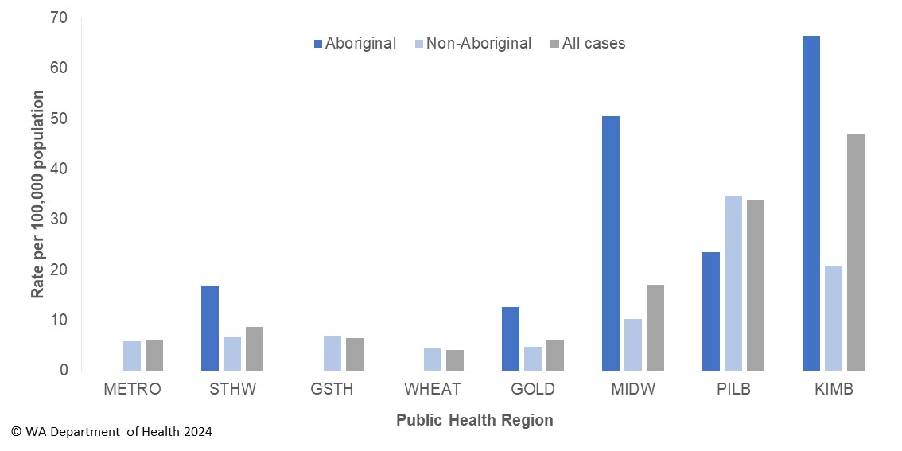

### Haemolytic Uraemic Syndrome (HUS)

Two cases of HUS were notified in 2023, consistent with the previous five-year average of two cases. The cases were aged 10 and 30 years old and both were diagnosed with an STEC infection and were investigated as part of the STEC serogroup O157:H7 community outbreak (see section: Significant probable foodborne outbreak summaries).

### Hepatitis A infection

There were 17 cases of hepatitis A notified in 2023 with a rate of 0.6 cases per 100,000 population compared to the previous five-year average of 0.4 cases per 100,000 population (Appendix 1). Of the 17 cases, 16 acquired their illness overseas and one in WA (Figure 7). The locally acquired case was infected by their sibling, who acquired their illness overseas.

Figure 7 Place of acquisition for hepatitis A notifications, 2018 to 2023

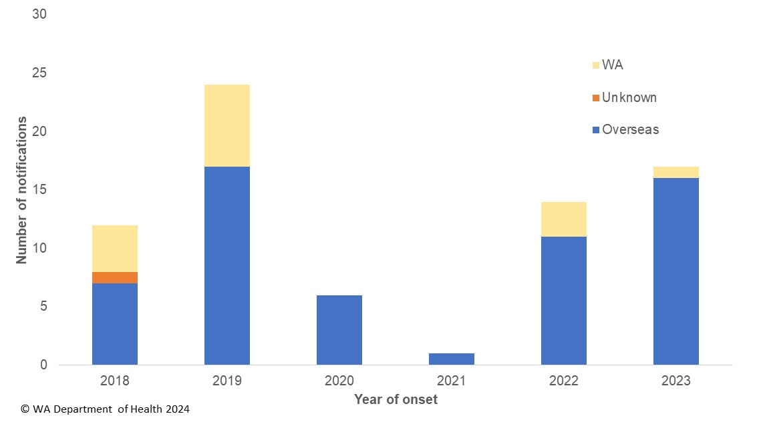

### Hepatitis E infection

There were seven cases of hepatitis E notified in 2023 compared to the previous five-year average of two cases. Three of the cases acquired their illness overseas (Pakistan n=2, Thailand n=1).

Three of the four locally acquired cases were part of national MJOI cluster of nine cases in total. No hypothesis for the cause of illness was established. The three WA cases were aged 44 to 50 years with two males and one female, all residing in metropolitan Perth, with illness onsets in March, May and December.

The fourth locally acquired case was in a 74-year-old male with onset in September and did not genomically cluster with other hepatitis E cases nationally.

### Listeriosis

There were six cases of listeriosisnotified in 2023 with a rate of 0.2 cases per 100,000 population, which was similar to the previous five-year average (Appendix 1). There were no materno-foetal pairs in 2023 (Figure 8). The six cases had immunocompromising and/or chronic disease conditions, ranged in age from 59 to 94 years, with three male and three female cases. Two deaths were temporally associated with the cases’ listeriosis diagnoses.

Figure 8 Notifications of listeriosis showing non-pregnancy related infections and deaths, and materno-foetal infections and deaths, WA, 2018 to 2023

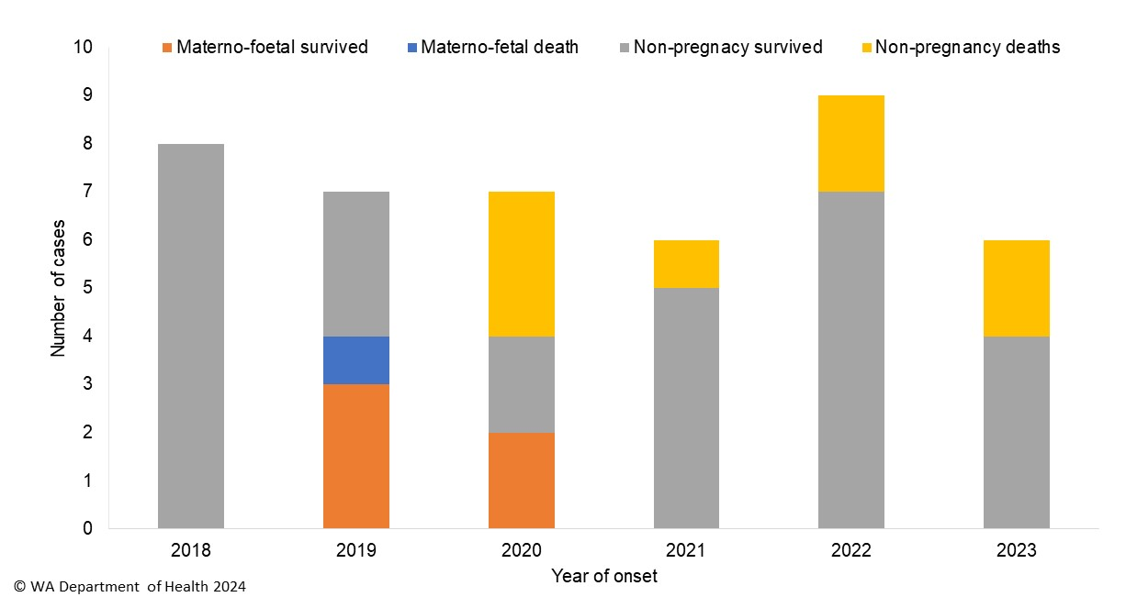

### Rotavirus infection

There were 911 cases of rotavirus infection in WA in 2023 with a rate of 33.9 per 100,000 population, which was 2.1-fold higher than the previous five-year average of 16.4 cases per 100,000 population (Appendix 1). Historically, rotavirus notifications peak in the winter months, but in 2023, cases increased from January to March (Figure 9).

Figure 9 Rotavirus notifications by year and month, WA, 2018 to 2023

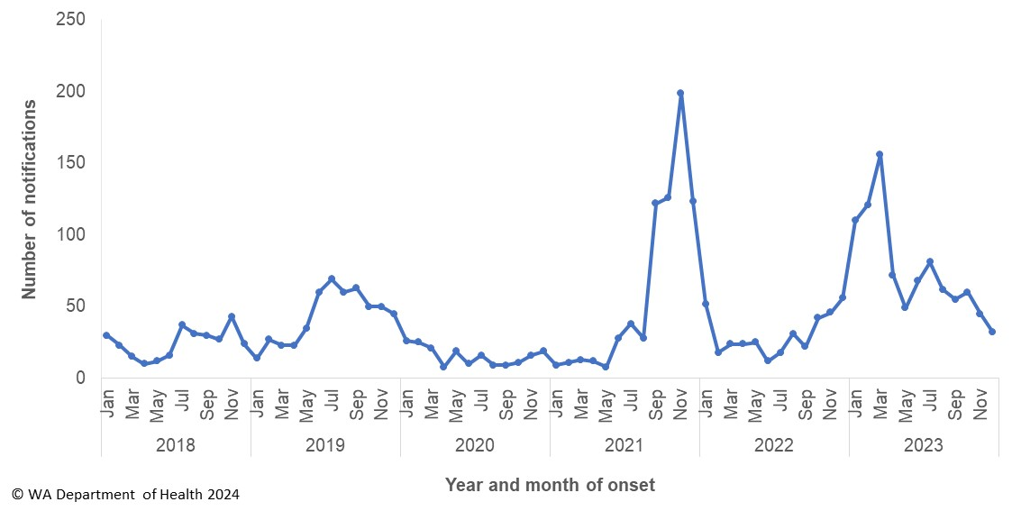

As with previous years, the age group with the highest rotavirus notification rate in 2023 was the 0–4 years group (262.1 cases per 100,000 population) (Figure 10). The overall notification rate was similar for females and males (34.8 and 33.0 per 100,000 population, respectively).

Figure 10 Rotavirus notification rates by age group and sex, WA, 2023

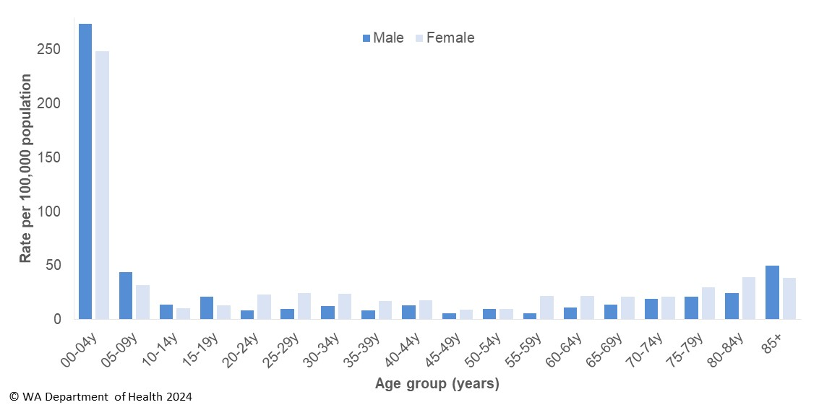

The regions with the highest rotavirus notification rates in 2023 were the KIMB and GOLD regions (85.4 and 64.6 cases per 100,000 population, respectively) (Figure 11). Overall, notification rates were 2.1 times higher for Aboriginal than for non-Aboriginal people (63.3 and 29.9 per 100,000 population, respectively). Of those rotavirus cases with known place of acquisition, 90% acquired their illness in WA and 10% were acquired overseas. There were six person-to-person outbreaks due to rotavirus in 2023, four in RCFs and two in CCC. In WA, rotavirus vaccination is available to infants at six weeks of age and is included in the childhood immunisation schedule.

Figure 11 Rotavirus notification rates by region and Aboriginality, WA, 2023

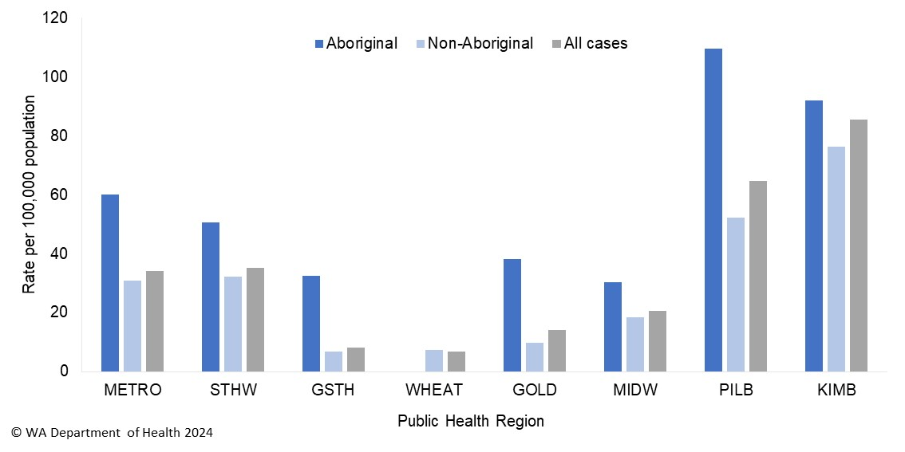

### Salmonellosis

Salmonellosis was the second most commonly notified enteric infection in WA in 2023 with 1,427 cases and rate of 53.1 cases per 100,000 population (Appendix 1), which was 11% lower than the previous five-year average (59.8 cases per 100,000 population). Historically, salmonellosis notifications are highest in the summer and autumn months, and a similar pattern occurred in 2023 (Figure 12).

Figure 12 Salmonellosis notifications by year and month, WA, 2018 to 2023

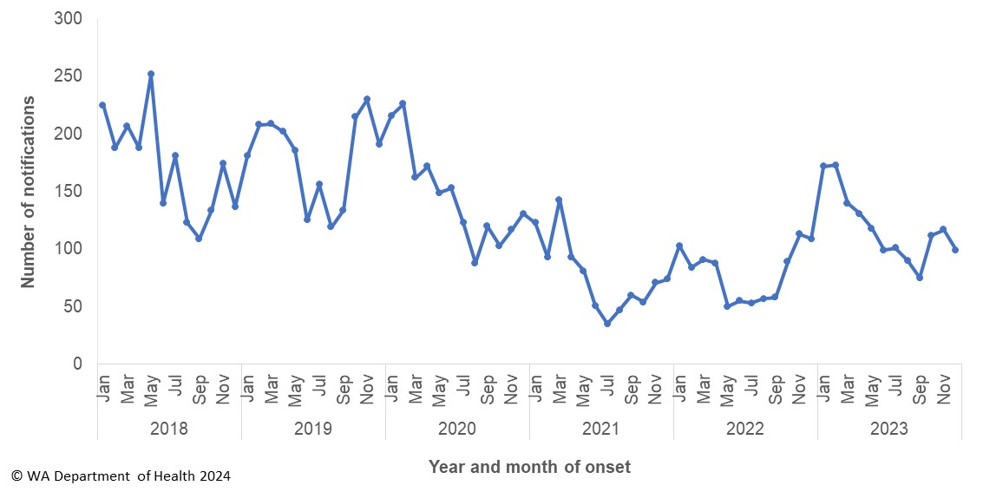

The notification rate for females was marginally higher than for males (56.5 and 49.5 per 100,000 population, respectively). As with previous years, the 0–4 year age group had the highest notification rate (184.9 per 100,000 population) (Figure 13). The age group 25–29 years had the next highest notification rate (67.6 per 100,000 population).

Figure 13 Salmonellosis notification rate by age group and sex, WA, 2023

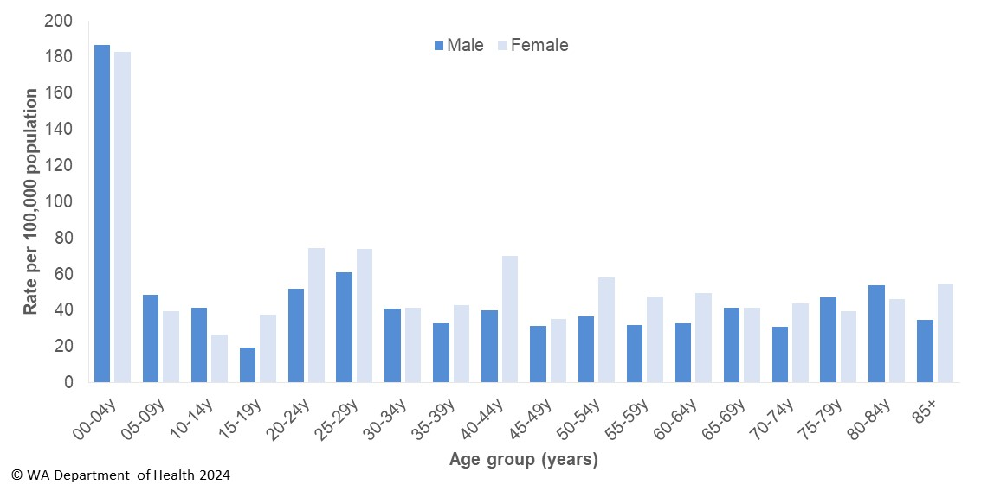

The salmonellosis notification rate for Aboriginal people was 82.3 cases per 100,000 population, which was 1.65 times higher than the notification rate for non-Aboriginal people (49.8 cases per 100,000 population).

The KIMB region had the highest notification rate in 2023 (217.9 per 100 000 population) which was five times the rate for the GSTH region, with the lowest notification rate (43.9 cases per 100 000 population) (Figure 14). The notifications in the KIMB region comprised 34 different serotypes and did not cluster in time or location.

Of those salmonellosis cases with known place of acquisition (70%), most (62%) cases acquired their illness in WA, 37% were acquired overseas and 1% of cases acquired their illness interstate (Figure 15).

Figure 14 Salmonellosis notification rates by region and Aboriginality, WA, 2023

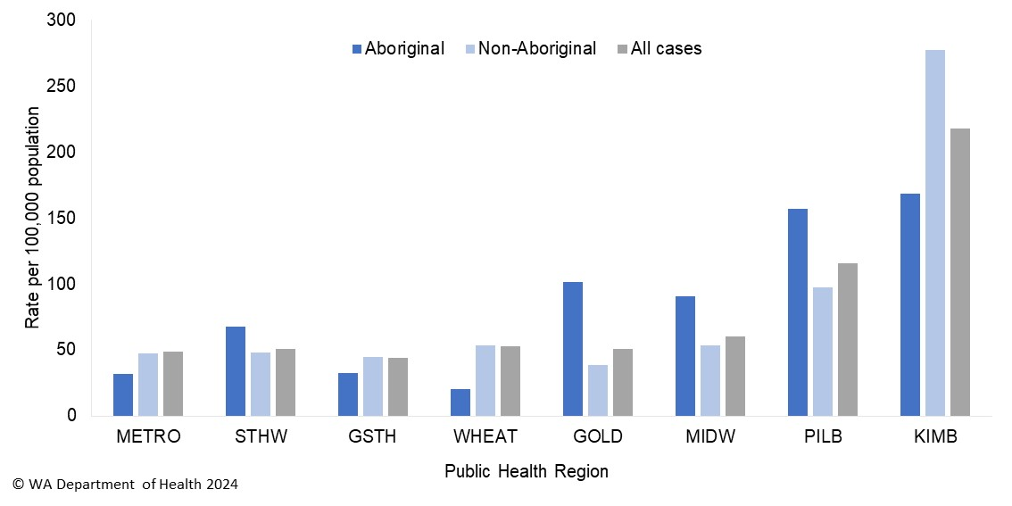

Figure 15 Salmonellosis notifications by place of acquisition and year, 2018 to 2023

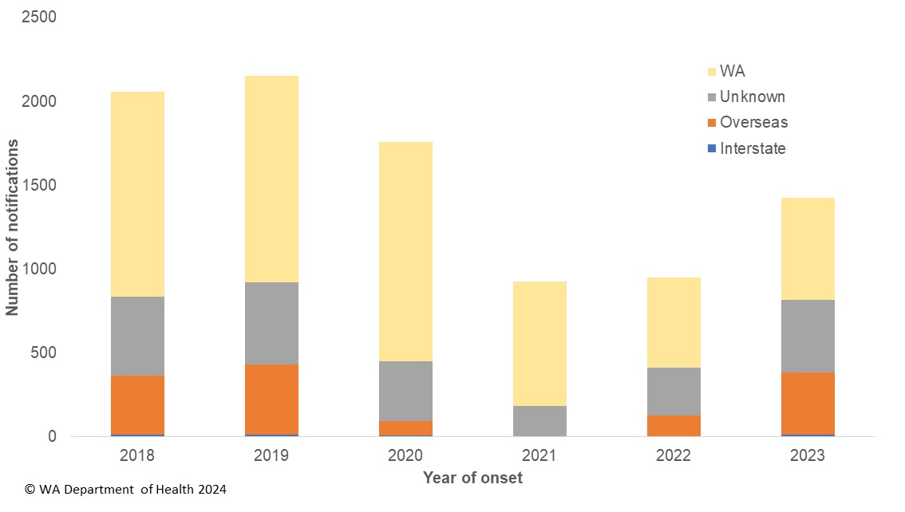

The most commonly notified *Salmonella* serovar in WA in 2023 was *S.* Typhimurium, with 284 notifications (Table 1), which was 20% of all *Salmonella* and 65% lower than the mean of the previous five years for *S.* Typhimurium. *S.* Typhimurium is further typed using MLVA and there were 142 MLVA types identified in 2023. Of these, the top 10 types comprised 34% (n=96) of the total *S.* Typhimurium notifications. The most common MLVA type (03-10-07-13-523) contributed 5% (n=15) of all *S.* Typhimurium notifications (Table 2). In 2023, a cluster of MLVA type 03-10-07-13-523 was investigated but the source of illness was not identified. The second most common MLVA type was 03-11-16-10-523 (n=13) and cases were not investigated as cases did not cluster in time or location. There were 13 cases of MLVA 03-16-09-12-523 and these cases were investigated as a cluster but the cause of illness could not be established. The next common MLVA type was 03-18-08-12-523 had 11 cases and the illness of 10 cases was associated with eating at a café (see significant outbreak summary).

The second most commonly notified serovars was *S*. Enteritidis with 163 notifications, which was 1.67-fold higher than the previous five year average for this serovar (Table 1). Most (87%) infections of this serovar were acquired overseas. In 2023, there were 19 cases of *S*. Enteritidis that were locally acquired. Cases were interviewed but the source of illness was not identified for most cases, except for four cases that were associated with eating food at a restaurant (see significant outbreak summary).

There were 183 (13%) *Salmonella* cases in 2023 where a serovar was not determined.

Table 1 Number and proportion of the top 10 *Salmonella* serotypes notified in WA, 2023, with comparison to the previous five-year average



a Percentage of total *Salmonella* cases notified in 2023.

b Ratio of the number of reported cases in 2023 compared to the previous five-year average of 2018–2022.

Table 2 The 10 most common *S*. Typhimurium MLVA types reported in 2023



aPercentage of total *S*.Typhimurium cases notified in 2023.

### Shiga toxin-producing *E. coli* (STEC) infection

There were 217 cases of STEC reported in 2023 with a rate of 8.1 cases per 100,000 population, which was 1.6-fold higher than the previous five-year average (Appendix 1). Some of the increase in 2023 was likely attributed to one pathology laboratory introducing STEC PCR tests in March 2022 on all stool specimens requesting stool culture. This laboratory notified 80% of STEC cases in WA for 2023. In 2023, STEC notifications peaked in January with 42 notifications and were generally lower in the middle of the year but peaked again in November with 24 notifications. (Figure 16).

Figure 16 STEC notifications by year and month, WA, 2018 to 2023

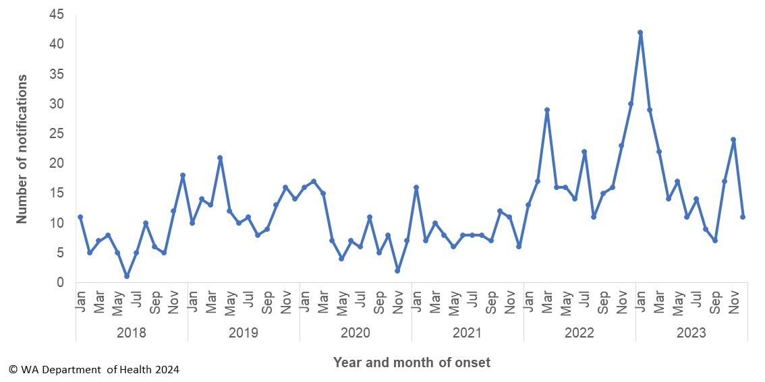

STEC notification rates in 2023 were highest in adults ≥75 years. The notification rate for females was 42% higher than males (9.4 and 6.7 per 100 000 population, respectively). The largest rate difference was in the 80–84 years age group with the female rate 3.4-fold higher than that seen in males. (Figure 17). The region with the highest notification rate was the KIMB with 32.4 cases per 100,000 population. The notification rate for Aboriginal people (14.5 cases per 100,000 population) was 1.9-fold higher than the rate for non-Aboriginal people (7.4 cases per 100,000 population).

Figure 17 STEC notification rates by age group and sex, WA, 2023

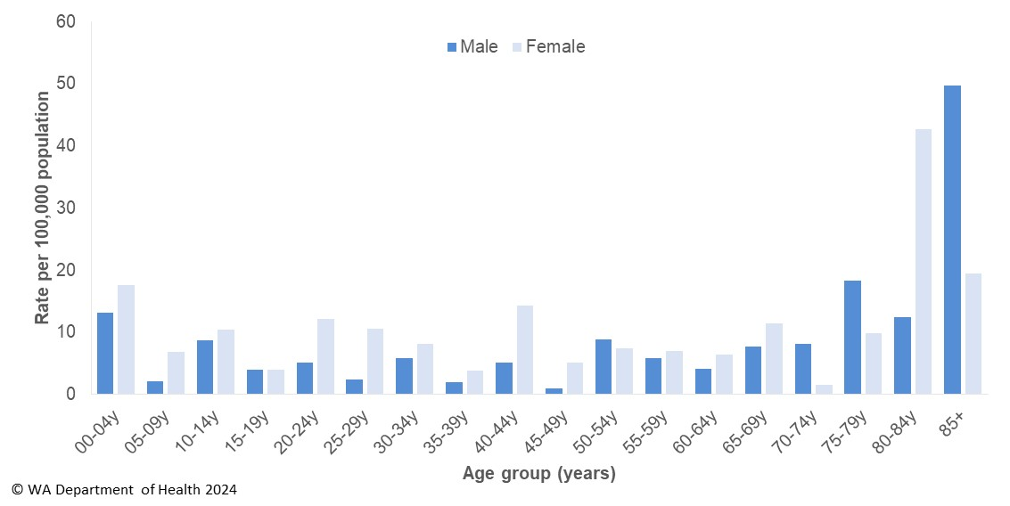

There were 81 (37%) cases that were culture positive, with the main serotypes O157 (n=29), O26 (n=8), O91 (n=6) and O91 (n=4). Of the cases with known place of acquisition (n=120), most (88%) acquired their infection in WA and 11% were overseas acquired. An investigation of a community outbreak of serotype O157:H7 did not identify the source of infection.

### Shigellosis

There were 415 cases of shigellosis notified in 2023, with a notification rate of 15.4 per 100,000 population. The notification rate was 73% higher than the previous five-year average (Appendix 1). In previous years, there was an increase in notifications during late spring into the summer months. In 2023, there was a peak in February and again in July (Figure 18).

As of 1 July 2018 the national *Shigella* case definition changed to include PCR positive notifications as probable cases and culture positive notifications as confirmed cases. In 2023, there were 311 probable and 104 confirmed shigellosis cases.

Figure 18 Shigellosis notifications by year and month, WA, 2018 to 2023

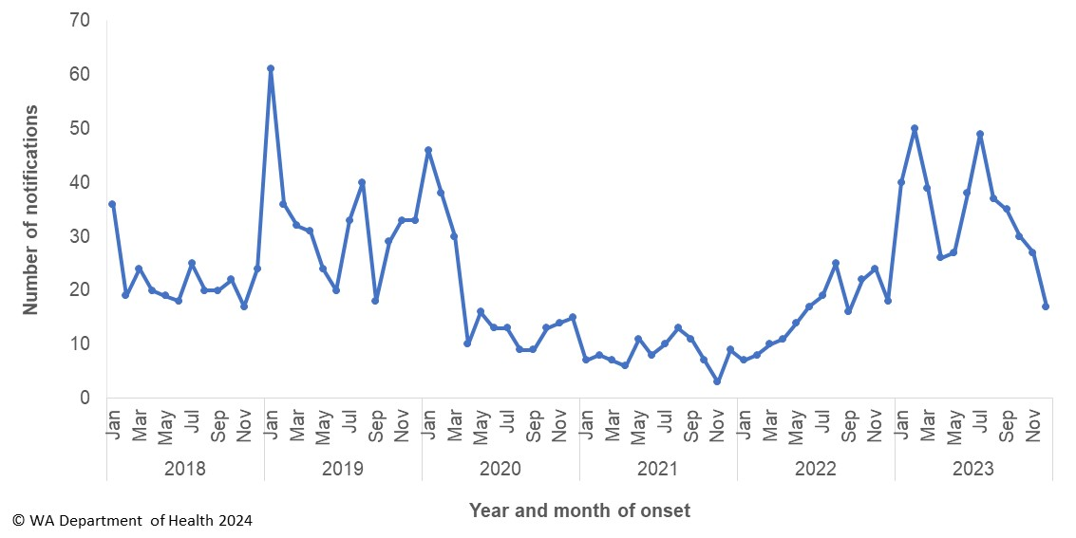

The shigellosis notification rate was 11% lower in females compared to males in 2023 (14.5 and 16.3 per 100,000 population, respectively). The 0–4 years age group had the highest rate of notification with 38.6 cases per 100,000 population (Figure 19).

Figure 19 Shigellosis notification rates by age group and sex, WA, 2023

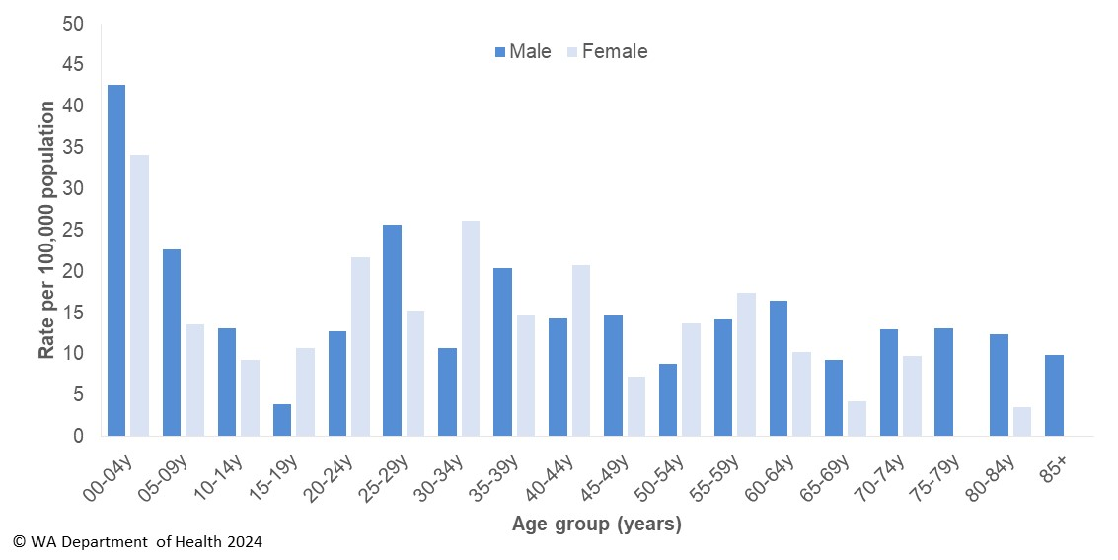

In 2023, the notification rate in Aboriginal people was four times higher than non-Aboriginal people (52.4 and 13.1 per 100 000 population, respectively). The region with the highest shigellosis notification rate was the KIMB (132.5 cases per 100,000 population) followed by the MIDW and METRO regions (18.8 and 14.8 cases per 100,000 population, respectively) (Figure 20).

Figure 20 Shigellosis notification rates by region and Aboriginality, WA, 2023

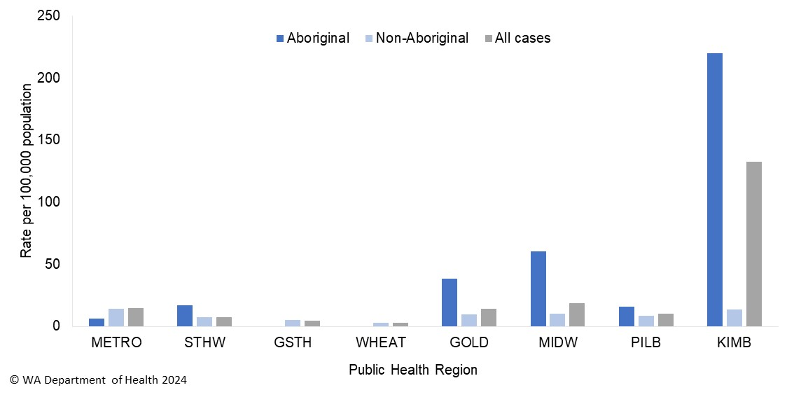

The predominant subtypes of *Shigella* notified in 2023 were *S. sonnei* biotypeG (n=33) and *S. flexneri* 2A (n=21).

There were 30 MDR *Shigella* notifications reported in 2023, compared to five in 2022. Of these,16 were *S. sonnei* biotype G and 12 cases identified as men who have sex with men. The remaining 14 MDR *Shigella* included three *S*. dysenteriae, nine *S. flexneri* and two *S. sonnei* biotype F. Notably, 12 of these 14 cases acquired their infection overseas.

### Typhoid and paratyphoid fever

In 2023, there were 22 cases of typhoid fever (caused by *Salmonella* Typhi) notified, which was 85% higher than the previous five-year average of 12 notifications (Appendix 1). All acquired their illness in overseas countries including India (n=17), Bangladesh (n=3) and Pakistan (n=2).

There were 15 cases of paratyphoid fever notified in WA in 2023 and all had travelled overseas with countries including India (n=12), Bangladesh (n=1), Indonesia (n=1) and Pakistan (n=1).

Of the 37 typhoid and paratyphoid cases, 18 (49%) were <15 years of age.

### *Vibrio parahaemolyticus* infection

There were 11 cases of *Vibrio parahaemolyticus* infection notified in 2023 with a rate of 0.4 cases per 100,000 population, which was 40% lower than the previous five-year average (Appendix 1). Of the 11 cases, six had acquired their infection overseas and one from interstate. There were four WA acquired cases, with one case each having gastroenteritis, an ear infection and a wound infection and one was tested as they had irritable bowel syndrome.

### *Yersinia* infection

There were 98 cases of culture-positive *Yersinia* *enterocolitica* infection notified in 2023, with a rate of 3.6 cases per 100,000 population, which is 4-fold higher than the average rate of the previous five years (Appendix 1). There were 57 female and 41 male cases with ages ranging between <1 years and 96 years (median 33 years). Of those cases with known travel history, 71% of cases had acquired their illness in WA, 22% acquired infections overseas and 7% acquired infections interstate. The majority (n=54) of cases were notified by one private pathology laboratory, which uses a faecal PCR test followed by reflex culture. There was one cluster investigation of *Y.* *enterocolitica* in the Pilbara region and the source was not identified.

# Gastrointestinal infection outbreaks and investigations

### Foodborne and probable foodborne outbreaks summary

In 2023, OFN investigated one foodborne and six probable foodborne gastroenteritis outbreaks in WA (Table 3).

The overall trend of foodborne and probable foodborne outbreaks is shown in Figure 21. In 2023, there was a 68% decrease in the number of outbreaks compared to the previous five-year average of 22 outbreaks. The seven outbreaks resulted in at least 110 cases, a 63% decrease compared to the previous five-year average of 298 cases. The decrease in the number of cases was also reflected in a decrease in hospitalisation, with 27 hospitalisations reported in 2023, a 22% reduction compared to the previous five-year average of 34.5. However, the proportion of outbreak-related cases hospitalised in 2023 was 25%, more than double the five-year average of 11% hospitalisation.

Table 3 Foodborne and probable foodborne outbreaks, 2023



**1**Month of outbreak is the month the outbreak was first reported or investigated, whichever is earliest.

2MLVA=multi-locus variable number tandem repeat analysis

3Evidence relates to determining mode of transmission. D=descriptive analysis. A=Analytical study.

Figure 21 Number of outbreaks and cases by year investigated, WA, 2018-2023

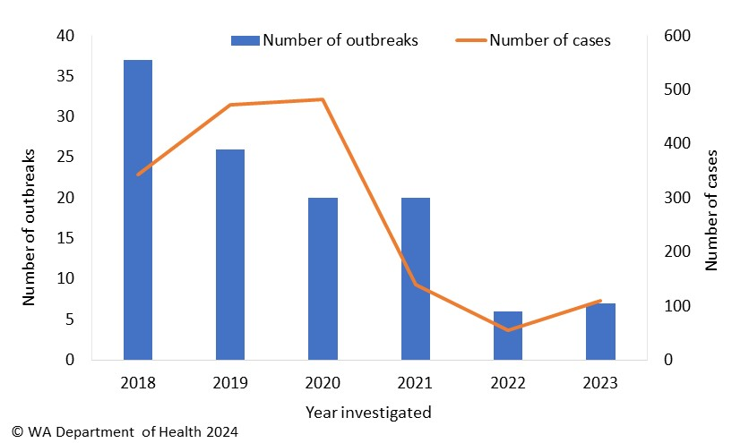

**Causative agents**

***Salmonella***

The top causative agent for foodborne outbreaks in 2023 was *Salmonella*, comprising five (71%) of the outbreaks investigated, with *S.* Typhimurium being the most common serovar (n=3/5; 60%) responsible for salmonellosis outbreaks.

The proportion of causative agents responsible for foodborne outbreaks investigated from 2018 to 2023 is shown in Figure 22. *S*. Typhimurium has remained the most prevalent pathogen causing outbreaks by year since 2018 and the most common implicated food was raw/undercooked egg dishes. However, there has been a decrease since 2020, mainly attributable to the work of the [*Salmonella* Task Force](https://www.health.wa.gov.au/~/media/Corp/Documents/Reports-and-publications/WA-foodborne-illness-reduction-strategy/Foodborne-strategy-taskforce.pdf), where the main intervention was the *Salmonella* vaccination of chickens at egg farms from June 2020 onwards. This vaccination led to reduced *Salmonella* contamination of eggs and decreased salmonellosis notifications in WA.

In contrast, from 2021 onwards the proportion of outbreaks caused by other non-typhoidal *Salmonella* serovars (non-*S*. Typhimurium) by year have slowly increased compared to other pathogens (Figure 22). In 2023, there was one (29%) foodborne outbreak caused by *S.* Saintpaul and one probable foodborne outbreak caused by *S.* Enteritidis. The *S.* Saintpaul outbreak was the largest outbreak of this serovar to-date in WA, with 76 cases, accounting for 65% (n=76/117) of all notified *S*. Saintpaul cases in 2023 (see significant outbreak summary)

**Shiga toxin producing *E. coli***

There was one probable foodborne outbreak of STEC serotype O157:H7 with nine cases linked by WGS analysis (see significant outbreak summary). WGS and cluster analyses have been utilised in WA since July 2021, which provides greater discrimination compared to other molecular typing techniques.

***Campylobacter* species**

While campylobacteriosis is the most commonly notified enteric infection in WA, minimal public health follow up is conducted due to the large number of notifications per year and lack of a routine typing method. Identification of potential clusters and outbreaks are mostly due to anecdotal reports of gastroenteritis associated with shared food at a venue, or food safety concerns from members of the public. In 2023, there was one probable foodborne outbreak of campylobacteriosis at a private gathering with three people ill, linked to the consumption of undercooked chicken kebabs.

Figure 22 The proportion of causative agents responsible for foodborne and probable foodborne outbreaks investigated in WA, 2018-2023

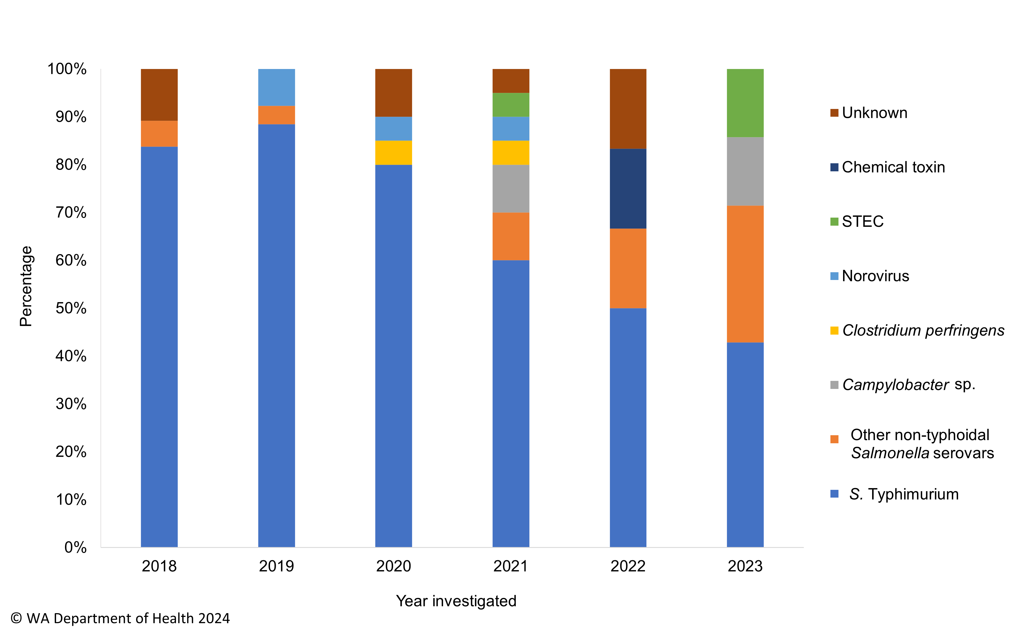

### MJOI of foodborne and probable foodborne outbreaks in WA

OFN WA participated in the investigation of seven foodborne and probable foodborne MJOIs in 2023, six of which included WA cases (Table 4). As WA cases in the *S.* Typhimurium MLVA 03-13-07-09-523 MJOI (which was led by WA) linked to consumption of baby cucumbers were reported from December 2022, details of this outbreak are described in the 2022 OFN WA annual report. There were no WA cases associated with MJOI 2023-002 *L. monocytogenes* MLST 5.

Table 4 Foodborne and probable foodborne MJOI case summary for WA, 2023



### Significant foodborne and probable foodborne outbreak summaries

**042-2023-001: *S.* Typhimurium MLVA 03-18-08-12-523 linked to a café**

An outbreak of 10 cases of *S.* Typhimurium MLVA 03-18-08-12-523 was investigated in January by WA Department of Health. All cases had eaten food from the same cafe and were not known to each other. The most common food item eaten by cases were banh mi rolls, chicken bao bun, roast beef roll and pork belly noodle/rice bowl. An environmental investigation identified that homemade raw egg mayonnaise was used at the premises. Eggs and fresh batches of mayonnaise sampled from the café were negative for *Salmonella*. The high pH of the egg mayonnaise indicated that the mayonnaise could potentially allow the growth of *Salmonella*. The eggs used by the café were traced back to a farm with historic on-farm detections of *S*. Typhimurium MLVA 03-18-08-12-523. Genomic relatedness between farm and clinical isolates of this *Salmonella* strain type was confirmed by WGS. Given the historic and genomic link of *Salmonella* strains from the farm and recent outbreak isolates, it is probable that one or more foods were contaminated with *Salmonella* from the eggs used at the food venue. The evidence suggests the mode of transmission was probable foodborne, but the food vehicle was unknown.

**088-2023-001:STEC O157:H7 MLST 2966 outbreak in the community**

The WA Department of Health investigated a community cluster of STEC serotype O157:H7 cases in February. There were seven female and two male cases with a median age of 29 years. Onset of illness ranged from 18 January to 3 February, with median duration of illness of 8 days. Two of the nine (22%) cases developed HUS.

Case interviews identified three common foods eaten; carrots, tomatoes and bagged salad mixes. Food traceback and retail sampling was conducted on 14 retail products, however STEC was not detected.

WGS and cluster analyses revealed cases were highly genomically related, suggesting a common source of infection. Overall, the descriptive evidence suggests the mode of transmission was probable foodborne, but the food vehicle was unknown.

**042-2023-002: *S.* Saintpaul outbreak**

In January, WA Department of Health coordinated an outbreak investigation of *S.* Saintpaul (MLST 50) in the community with 76 cases residing in five PHUs. There were 47 female and 29 male cases, median age 33 years and onset of illness ranged from 23 January to 3 March 2023. Binomial probability calculations of the 7-day food consumption frequency data collected from the first 23 interviewed cases were compared with data from a 2015/2016 Victorian population food frequency survey data. The analysis identified that bean sprouts were consumed at a significantly higher proportion among outbreak cases, suggesting bean sprouts may be a possible cause of illness.

A matched case-control study was conducted in February 2023, with 33 cases and 57 controls. Odds ratios (OR) calculated for 24 food items showed a significant association between *S.* Saintpaul infection and the consumption of any sprouts (OR=49, 95%CI: 3.9-614.9) and green capsicum (OR=9.5, 95%CI: 1.6-56.9).

Environmental health sampling was conducted at three main WA producers/growers of sprouts, as well as retail sampling of other common food items reported by cases. All environmental samples collected were negative for *Salmonella*.

Although the analytical evidence showed a statistically significant association between infection and consumption of any sprouts, there was no confirmatory microbiological evidence. WGS of *S.* Saintpaul isolates revealed a highly genomically-related cluster within a five-week period indicating a common source of infection. Overall, the analytical evidence suggests the mode of transmission was foodborne, and the food vehicle was likely be sprouts.

**042-2023-005: *S*. Enteritidis outbreak linked to a buffet venue**

Routine enhanced surveillance of *S*. Enteritidis notifications revealed a cluster of four highly genomically related cases using WGS. All four cases were female and unknown to each other, had no prior travel history but had eaten food at the same buffet venue over a three-week period. The onset dates of illness ranged from 23 July to 13 August 2023. Due to the wide variety of food items served at the dinner buffet service, food recall in some cases was poor and an implicated food was not identified.

An additional case that was highly genomically related to the four cases was diagnosed in August 2022 and had travelled to the Philippines. This finding suggested that the source of the infection at the venue might be linked to an ill or asymptomatic *S*. Enteritidis carrier who had recent travel history to the Philippines.

A staff survey at the venue collected information on work area, health status (focussed on gastroenteritis symptoms) and travel history but no staff were implicated. Other measures included, re-training on staff hand hygiene, increased frequency of deep cleaning and revision of food safety handing processes. Retention food samples tested were negative for *Salmonella*.

Overall, the evidence suggests the outbreak was probable foodborne via an unknown food vehicle.

### Outbreaks due to non-foodborne transmission or unknown mode of transmission

In 2023, there were 219 outbreaks of gastroenteritis investigated that were not classified as foodborne or probable foodborne outbreaks (Table 4). These included 208 outbreaks associated with probable person-to-person transmission (PTP) and 11 outbreaks where the mode of transmission was unclear or unknown (Figure 21).

**Probable person-to-person outbreaks**

The number of PTP outbreaks in 2023 was 19% higher than the average of the previous five years (n=175). The most common setting for PTP outbreaks were RCFs (n=118, 57%) and CCCs (n=84, 40%). The majority of PTP outbreaks were reported in the first and fourth quarter of 2023 (Figure 21). CCC outbreaks accounted for the majority of PTP outbreaks in 2021 (n=159/246, 65%) and 2022 (n=74/151, 49%). The remaining PTP outbreaks in 2023 occurred in schools (n=2), private residences (n=2), an institution (n=1) and a workplace (n=1) (Table 4).

The causative agent for 81 (39%) of the outbreaks was confirmed as norovirus, six outbreaks were due to rotavirus, two due to *S.* Typhimurium and one outbreak was due to sapovirus. In the remaining 118 outbreaks, the causative agent was unknown, either because specimens were not collected, a pathogen was not identified during testing, viral testing was not requested, or it was not clear from the results what the causative pathogen was.

For the 208 PTP outbreaks, at least 3,815 people were ill, with 69 hospitalisations and 18 associated deaths.

**Outbreaks with unknown mode of transmission**

There were 11 outbreaks where the likely mode of transmission was unclear or unknown. Of these, five occurred in RCFs and six occurred in CCCs, all had an unknown causative agent and there was insufficient information to attribute a mode of transmission (Table 4).

Figure 21 Number of non-foodborne gastroenteritis outbreaks by mode of transmission and month, 2023

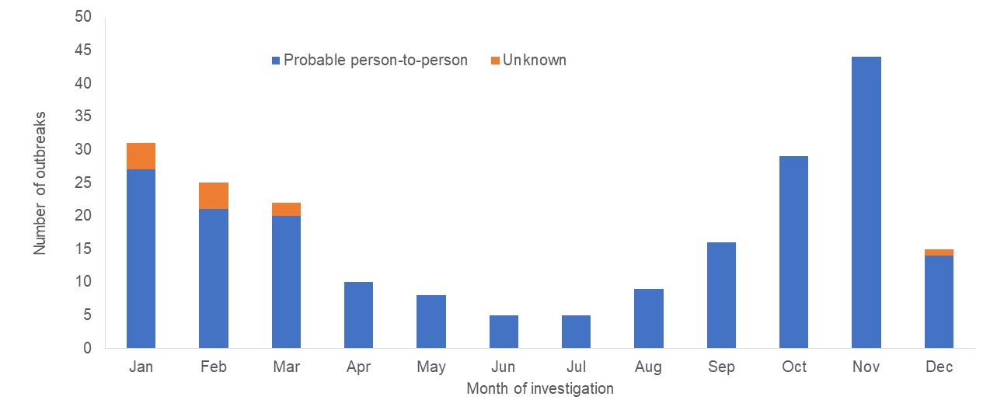

**Table 4 Outbreaks due to non-foodborne or unknown mode of transmission in WA by setting and agent, 2023**



*STM=*Salmonella* Typhimurium

1Deaths temporally associated with gastroenteritis, but contribution to death not specified.

### Cluster investigations

A cluster is defined as an increase in infections that are epidemiologically related in time, place or person where investigations are unable to implicate a vehicle or determine a mode of transmission responsible for the increase.

In 2023, there were nine clusters investigated which included eight *Salmonella* clusters and one cluster of yersiniosis (Table 5) with a total of 52 people ill. Cases were interviewed with standard hypothesis generating questionnaires but no hypothesis for the cause of illness could be established.

**Table 5 Cluster investigations in WA by month investigation started, setting and agent, 2023**



*MLVA=multi-locus variable number tandem repeat analysis

# References

Hall, G., Kirk, MD., Becker, N., Gregory, JE., Unicomb, L., Millard, G., et al. Estimating foodborne gastroenteritis, Australia. Emerg Infect Dis 2005;11(8):1257-1264.

OzFoodNet Working Group. A health network to enhance the surveillance of foodborne diseases in Australia. Australian Government Department of Health and Aged Care 2023. <https://www1.health.gov.au/internet/main/publishing.nsf/Content/cdna-ozfoodnet.htm>

Western Australian Department of Health. A-Z list of case definitions. Western Australian Department of Health 2020. <http://ww2.health.wa.gov.au/Articles/N_R/Notification-of-infectious-diseases-and-related-conditions>.

Communicable Diseases Network Australia. [Australian national notifiable diseases and case definitions](https://www.health.gov.au/resources/collections/cdna-surveillance-case-definitions). Australian Government Department of Health and Aged Care 2023

<http://www.health.gov.au/casedefinitions>

Ng, J., Eastwood, K., Walker, B., Durrheim, DN., Massey, PD and Porigneaux, P. Evidence of Cryptosporidium transmission between cattle and humans in northern New South Wales. Exp Parasitol 2012;130(4):437-441.

# Appendix 1: Number of notifications, notification rate2 and ratio of current to historical average by pathogen/condition, 2018 to 2023, WA



1Abbreviations: STEC: Shiga toxin-producing *E. coli*; HUS: Haemolytic Uraemic Syndrome; NA: not applicable. 2Rate is cases per 100,000 population. 3*Shigella* includes probable and confirmed notifications as of 1 July 2018; the five-year average should be interpreted with caution.

**This document can be made available in alternative formats on request for a person with a disability.**

© WA Department of Health 2024

Copyright to this material is vested in the State of Western Australia unless otherwise indicated. Apart from any fair dealing for the purposes of private study, research, criticism or review, as permitted under the provisions of the *Copyright Act 1968*, no part may be reproduced or re-used for any purposes whatsoever without written permission of the State of Western Australia.